1-The average number of faulty products produced by a machine is 4,300 acres per year, with a standard deviation of 750 acres. The distribution of the number of faulty products is normal.

What is the probability that between 2,500 and 4,200 faulty products produced in any given year?

a) 0.4402

b) 0.5

c) 1

d) All of the mentioned

ANSWER: a

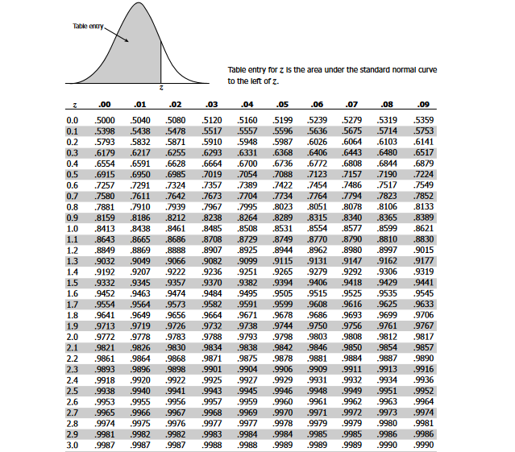

2. It is known that in a certain town 30% of the people use Iphone. researcher asks people at random whether they own an Iphone. The random variable X represents the number of people asked up to and including the first person who owns an Iphone. Determine that P 6 ( X <6 )(Hint: Geometrical distribution)

a) 0.2402

b) 0.1380

c) 0.8319

d) None

3. Weighting time is uniformly distributed in some shop is 1 to 5 mins. Probability of weighting between 2 to 3 mins.

a) 0.50

b) 0.75

c) 0.25

d) 0.20

ANSWER: c

4. A random variable X has following PDF: f(x) = 3x2 0≤x≤1.

(a) Find P(X≥0.45).

(b) Find a such that P(X≤a) =P(X > a)

(c) Find b such that P(X > b) = 0.35

5. Suppose the mean number of minutes between eruptions for a certain geyser is 40 minutes.

What is the probability that we’ll have to wait less than 50 minutes for an eruption?

6. Let X = amount of time (in minutes) a postal clerk spends with his or her customer. The time is known to have an exponential distribution with the average amount of time equal to four minutes. Find the probability that a clerk spends four to five minutes with a randomly selected customer.